**Lab 11**

**Lab Task 11.1) Write a program to calculate the factorial of the input number.**

#include <iostream>

using namespace std;

int main()

{

int a,b=1;

cout << "Enter a positive integer: "<<endl;

cin >> a;

for(int i = 1; i <=a; ++i)

{

b *= i; //expression is b=a*i

}

cout << "Factorial of " << a << " = " << b;

return 0;

}

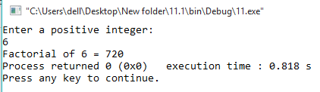

**Lab Task 11.2) Write a program to check the input is a prime number or not.**

#include <iostream>

using namespace std;

int main()

{

int a,b=0,c=0,i;

cout << "Enter a number " << endl;

cin>>a;

c=a/2;

for(i=2; i<=c; i++ )

{

if(a%i==0)

{

cout<<"number is not a prime."<<endl;

b=1;

break;

}

}

if(b==0)

cout<<"number is prime."<<endl;

return 0;

}

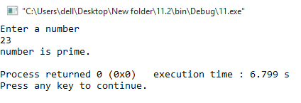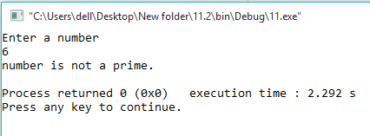

**Lab Task 11.3) Write a program to generate a Fibonacci Series of given number of terms**

#include <iostream>

using namespace std;

int main()

{

int n, t1 = 0, t2 = 1, nextTerm = 0;

cout << "Enter the number of terms: ";

cin >> n;

cout << "Fibonacci Series: ";

for (int i = 1; i <= n; ++i)

{

// Prints the first two terms.

if(i == 1)

{

cout << " " << t1;

continue;

}

if(i == 2)

{

cout << t2 << " ";

continue;

}

nextTerm = t1 + t2;

t1 = t2;

t2 = nextTerm;

cout << nextTerm << " ";

}

return 0;

}

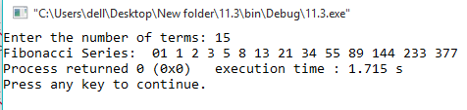

**Lab Task 11.4) Write a program to draw the following pattern**

#include <iostream>

using namespace std;

int main()

{

int a,b;

for (int a=1; a<=5; a++ ) //for no of rows

{

for (int b=1; b<=a; b++ ) //for number of colunms

{

cout<<b;

}

cout <<"\n"; //to jump to next line after a loop

}

return 0;

}

